# **CSC2402 Assignment 3**

# **By Peter Compton – U1077579**

## **Output Screenshots:**

## **Question 1**

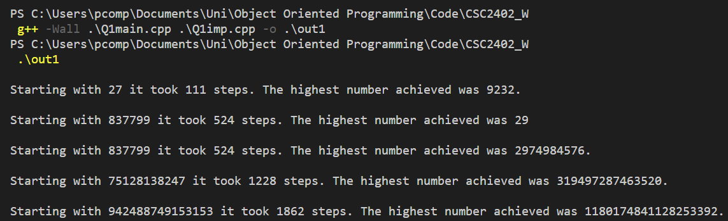

## **Question 2**

